| :росток:Beet Seed — відпрацюй навички на базовому рівні.  Протестуй UI/UX сайту [Оксфорд Медикал](https://oxford-med.com.ua/). В Google docs створи 5 багів з дотриманням усіх вимог до оформлення багу.  *Відповіді до завдань запиши у файл Google Docs. Додай посилання на нього в LMS.* |
| --- |
| :травы: Beet Sprout — детальніше заглибся в практику.  1. Виконай завдання попереднього рівня.  2. Проведи кросбраузерне тестування знайдених раніше багів у трьох різних браузерах.  3. Додай результати до зафіксованих раніше багів. |

1. Telephone number is not validated in the call back form in the header.

**Description**:

When entering invalid telephone number in the call back form in the header of the website, the form accept it without validation of the telephone number.

**Steps to reproduce:**

1. Open website [https://oxford-med.com.ua/ua/](https://oxford-med.com.ua/ua/#).
2. Click on the arrow down near the contact phone number on the header to open the call back form.
3. Enter invalid phone number and click OK button.

**Actual result:** The successful request pop-up is shown.

**Expected result:** The pop-up or notification with invalid phone number should be shown.

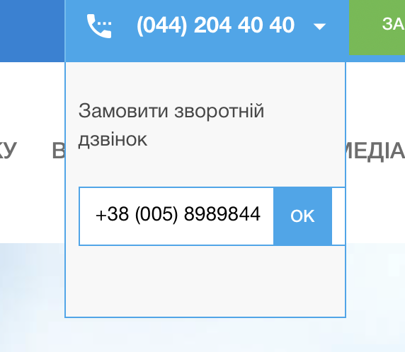

**Tested on:** MacOS, Safari Version 17.3.1 (19617.2.4.11.12).

2. The main menu is not centered in UA and RU versions.

**Descriptions:**

The main menu below the header is not centered in UA and RU versions of the website.



**Steps to reproduce:**

1. Open the webpage [https://oxford-med.com.ua/ua/](https://oxford-med.com.ua/ua/#).
2. Look on the main menu.

**Actual result:** The main menu is not centered in UA and RU versions and closer to the left side of the page.

**Expected result:** The main menu should be centered, the same as the header.

**Tested on:** MacOS, Safari Version 17.3.1 (19617.2.4.11.12).

1. The hidden information in the “Our contacts” in the webpage body menu should be visible.

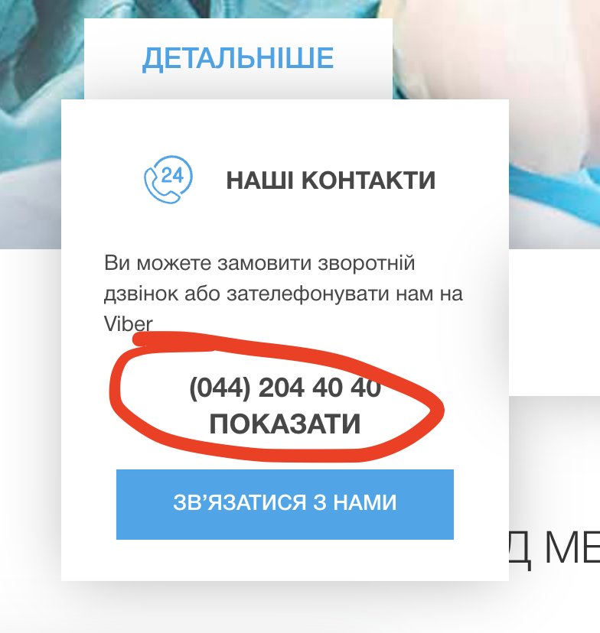

**Descriptions:** When hovering the “Our contacts” menu in the body of the webpage, it doesn't show an additional phone number, but instead shows the additional line “show” that has to be clicked to show one more phone number.

**Steps to reproduce:**

1. Open the webpage [https://oxford-med.com.ua/ua/](https://oxford-med.com.ua/ua/#).
2. Scroll down to the body of the website and look at the “Our contact” menu in the left side.
3. Hover the cursor.

**Actual result:** It shows the additional line “show” that has to be clicked to show one more phone number.

**Expected result:** The additional phone number should be shown by default if there is only one additional phone number.

**Tested on:** MacOS, Microsoft Edge Version 122.0.2365.59 (Official build) (arm64).

4.Footer section “Information” does not have any information.

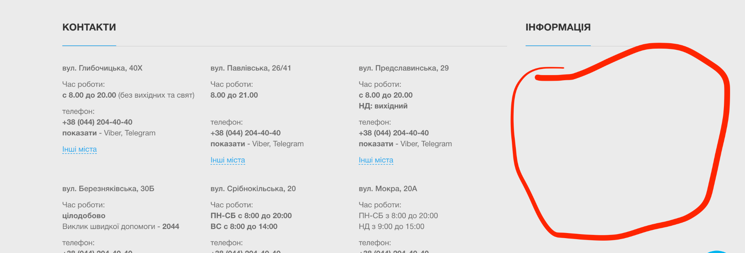

**Descriptions:** When looking at the “Information” section in the footer left side, it is empty and does not include any information.

**Steps to reproduce:**

1. Open the webpage [https://oxford-med.com.ua/ua/](https://oxford-med.com.ua/ua/#).
2. Scroll down to the footer and look at the left side where the “Information” section is located.

**Actual result:** The “Information” section is empty.

**Expected result:** Some information should be in the “Information” section.

**Tested on:** MacOS, Microsoft Edge Version 122.0.2365.59 (Official build) (arm64).

5.Different style of working hours and days for different cities in the “Contact section”.

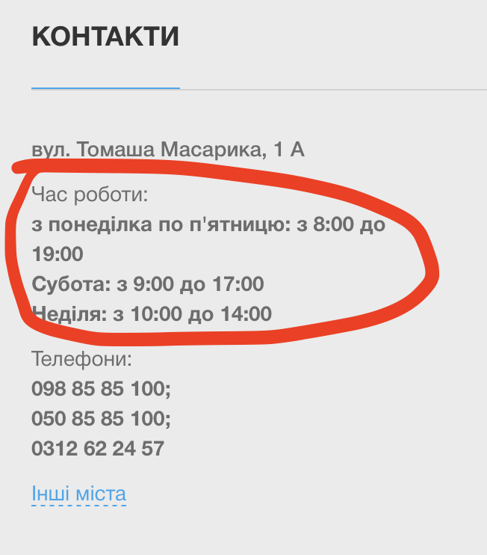

**Description:** When looking at “Contact” section in the footer of the website and comparing it with different cities, it shows different formats of working days and hours.

**Steps to reproduce:**

1. Open the webpage [https://oxford-med.com.ua/ua/](https://oxford-med.com.ua/ua/#).
2. Scroll down to the footer and look at the right side where the “Contact” section is located and compare the format of working days for different cities.

**Actual result:** The format of working days for different cities is different, that cause bas customer experience.

**Expected result:** The format of working days for different cities should be the same and unified.

**Tested on:** MacOS, Safari Version 17.3.1 (19617.2.4.11.12).